Oaths
Fol.21.35
To get naming for oaths (either name of Committee or position under the person’s name on the Oath.)
Save as: Document
Naming conventions:
Oath date xx-xx-xxxx, (use sworn in date) first and last name, Title or committee
Refined search by:
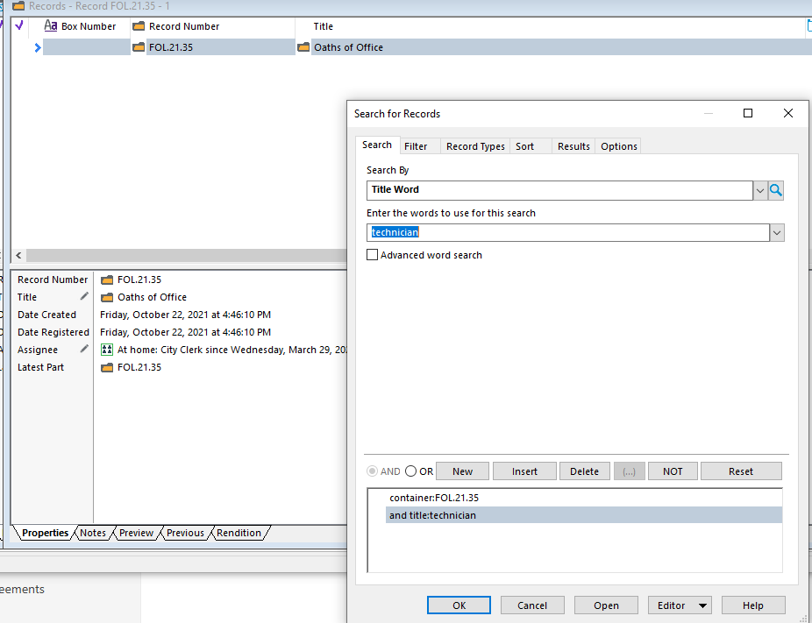

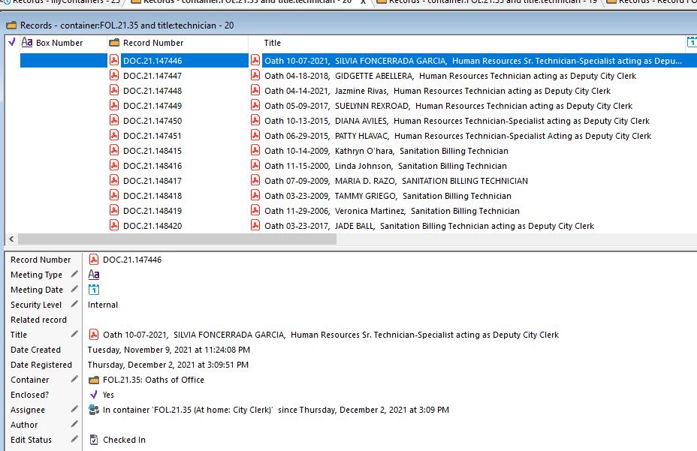
Once uploaded email City Clerk, All Staff and the clerk who sent it to be uploaded.

